COPYMASTER |  |  | VERSION: 1.02
Project Name: Mufasa_FRX | Product Name: Acer Nitro 16 | Product Type: Entry level gaming laptop
Writer: Clark Gurden | PMKT: Sylvia Pan | FCS: 6/05/26
Updates
UNDER EMBARGO
1.01
NV
PC game pass
Spec line (overline removed)
Modified sections highlighted in yellow
Swapped ksp 3 and 4 (wifi first)
1.02
Updated NV main ksp msg
H2/H3

AGW Meta Content
Page Title (60) | Acer Nitro 16 | Everyday Performance Gaming Laptop
Meta Description (160) | Acer Nitro 16 packs everyday speed with up to an AMD Ryzen™ 9 9955HX3D processor, an NVIDIA® GeForce RTX™ 5070 Ti Laptop GPU, and up to a 240Hz WQXGA display
Product Card Description (120) | A 16-inch everyday performance gaming laptop built for fast play and heavier loads.

AGW Page Content
Product Name |  | Acer Nitro 16
Tagline (60)
Key Message/Page Intro
Key Message/Intro (220) |  | Built for faster play under heavier load, this everyday gaming laptop combines up to an AMD Ryzen™ 9 9955HX3D processor with NVIDIA® GeForce RTX™ 50 Series Laptop GPU performance, a fast 16-inch display, and cooling tuned to keep pace.
Copilot+PC/Windows Message |  | Windows is fast, powerful, and more secure than ever.  Meet the Computer you can talk to.
CTA Button |  | Watch Video
CTA Button Link |  | https://youtu.be/dErqF3-2Z-g
Logos / Badges / Awards
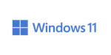 | 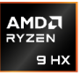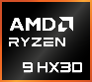 |  | 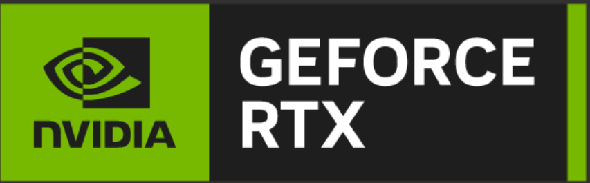 |  |  |  | Wi-fi 6e |  | PC game pass
Media Reviews – ENGLISH (ENG)
Publish to USA / CA
Section Headline |  | Media Reviews
Text Content
Image Selection |  | Generic |  | Generic |  | Generic |  | Generic
Reviewer Name
Quote (180)
Button & URL |  | Read More |  | Read More |  | Read More |  | Read More

H2 Partner KSP 1
Image Ref |  | Confirm with Jane/Jen
KSP Headline |  | The Ultimate Gaming Edge
KSP Body |  | AMD has now combined its top-end processors with cutting-edge AMD 3D V-Cache™ technology. This means that enthusiasts can harness the power of the ultimate gaming and creator performance in one. No workload is off limits with up to an AMD Ryzen™ 9 9955HX3D processor.
Spec (30) |  | Windows 11 Home | Up to AMD Ryzen™ 9 | Up to 16 Cores | Up to 5.4 GHz
Underline (20) |  | Operating System | 9955HX3D processor | 32 Threads | Max Boost Clock
H2 Partner KSP 2
Tagline |  | RTX. It’s On.
Series Headline |  | The Ultimate in Ray Tracing and AI
Tech Headline |  | RTX is the most advanced platform for path tracing and neural rendering technologies that are revolutionizing the ways we play and create. Over 800 games and applications use RTX to deliver realistic graphics and incredibly fast performance with cutting-edge AI features like DLSS Multi Frame Generation.
Spec Component
Spec (30) |  | Up to NVIDIA® GeForce RTX™ 5070 Ti |  | 5th Gen Tensor Cores Max AI Performance
Underline (20) |  | Laptop GPU (992 AI TOPS) |  | with FP4 & DLSS 4.5
H3 Partner KSP 2.1
Image reference |  | 
Tech Headline |  | NVIDIA DLSS 4.5
KSP Headline |  | Supreme Speed. Superior Visuals. Powered by AI.
KSP Body |  | DLSS is a revolutionary suite of neural rendering technologies that uses AI to boost FPS, reduce latency, and improve image quality. DLSS 4 introduced Multi Frame Generation (MFG) and transformer models. DLSS 4.5 brings Dynamic MFG and a second-gen transformer model. All backed by an NVIDIA AI supercomputer in the cloud, constantly improving your PC’s gaming capabilities.
H3 Partner KSP 2.2
Image reference |  | 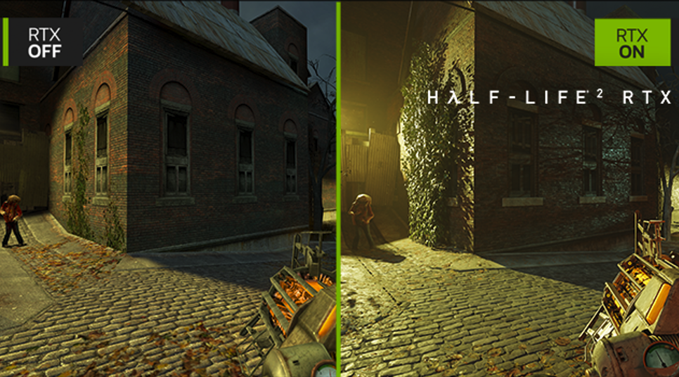
Tech Headline |  | Path Tracing with Neural Rendering
KSP Headline |  | Game-Changing Realism
KSP Body |  | The NVIDIA Blackwell architecture unlocks the game-changing realism of path tracing. Experience cinematic quality visuals at unprecedented speed powered by GeForce RTX 50 Series with fourth-gen RT Cores and breakthrough neural rendering technologies accelerated with fifth-gen Tensor Cores.
H3 Partner KSP 2.3
Image reference |  | 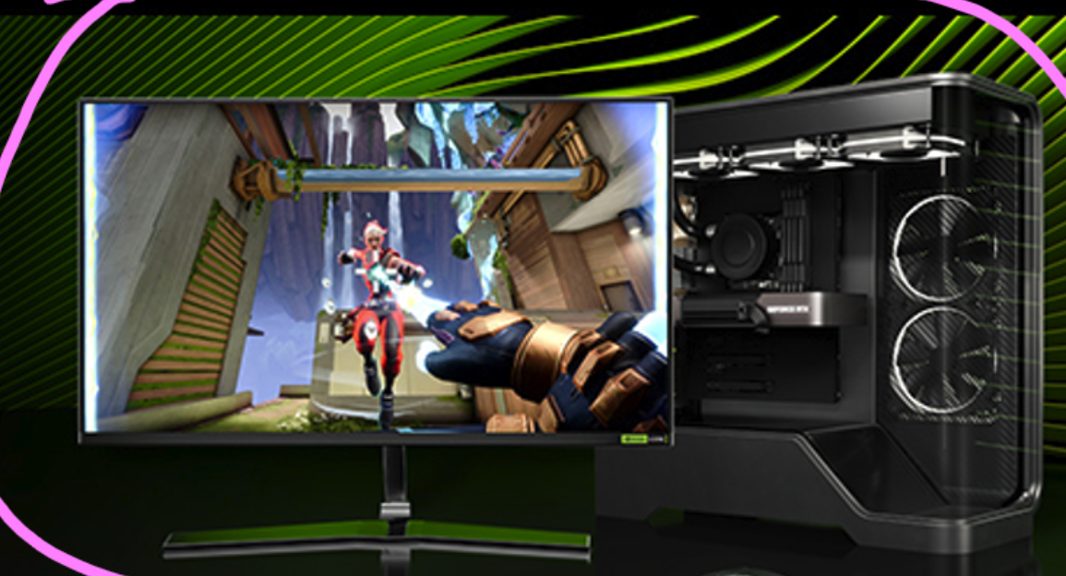
Tech Headline |  | NVIDIA REFLEX 2
KSP Headline |  | Compete at Warp Speed
KSP Body |  | Reflex technologies optimize the graphics pipeline for ultimate responsiveness, providing faster target acquisition, quicker reaction times, and improved aim precision in competitive games. Reflex 2 introduces Frame Warp, which further reduces latency based on the game’s latest mouse input.
H3 Partner KSP 2.4
Image reference |  | 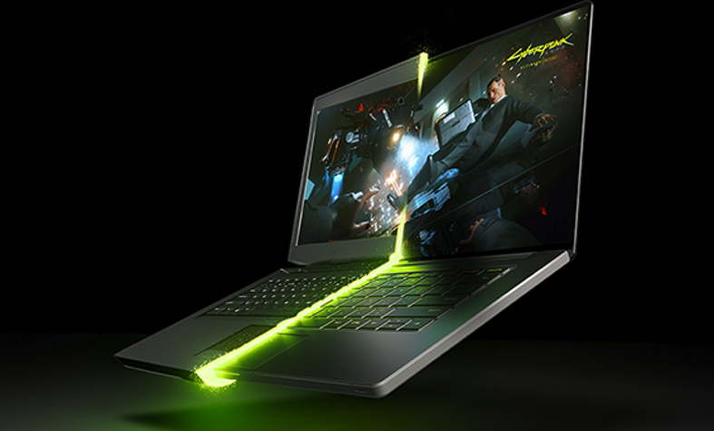
Tech Headline |  | NVIDIA Blackwell Max-Q
KSP Headline |  | Optimized Power and Performance
KSP Body |  | Max-Q is designed from the ground up for maximum efficiency, delivering a massive leap in performance and battery life.
H3 Partner KSP 2.5
Image reference |  | 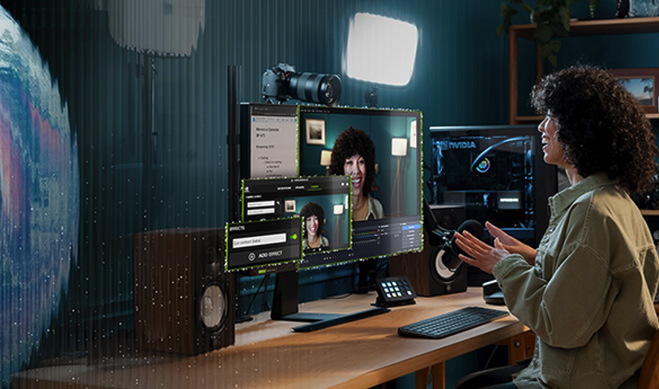
Tech Headline |  | RTX AI PC
KSP Headline |  | NVIDIA Powers the  World’s AI. And Yours.
KSP Body |  | Upgrade to advanced AI with NVIDIA GeForce RTX™ GPUs and accelerate your gaming, creating, productivity, and development. Thanks to built-in AI processors, you get world-leading AI technology powering your Windows PC.
H2 KSP 3
Image reference |  | 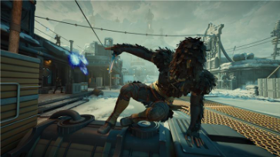
KSP Headline (30) |  | More View for Faster Play
KSP Body (180) |  | The 16-inch 16:10 display gives you more room to track the action, manage overlays, and stay locked in. With vivid color and up to a 240Hz refresh rate, motion stays sharper when matches speed up.
Spec (30) |  | 16” WQXGA | Up to 240Hz | 16:10 | MUX Switch
Underline (20) |  | 2560 x 1600 Display | Refresh Rate | Aspect Ratio | Equipped
H3 KSP 3.1
Image reference |  | 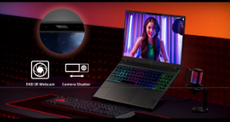  remove camera shutter icon
KSP Headline (30) |  | Sharper Focus
KSP Body (180) |  | The FHD IR camera delivers crisp, consistent image quality for streaming, squad coordination, and competitive play, keeping you visible and locked in when every call counts.
H2 KSP 4
KSP Headline (30) |  | Optimized Cooling with Vector Heat Pipes
KSP Body (180) |  | Dual fans, quad-intake airflow, quad-exhaust venting, and vector heat pipes move heat out fast, helping the system stay steadier when gaming sessions, streams, and multitasking stacks start to hit harder.
H2 KSP 5
Image reference |  | 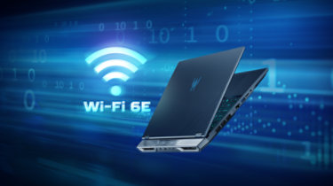
KSP Headline (30) |  | Fast Wired and Wireless
KSP Body (180) |  | Wi-Fi 6E and Killer™ Ethernet E3100G help support smoother online play, more stable downloads, and dependable connections at home, in a dorm, or on campus.
H2 KSP 6
Image reference
KSP Headline (30) |  | Ports Ready to Connect
KSP Body (180) |  | USB4®, HDMI 2.1, USB Type-A, microSD, and RJ45 give you the connections to hook up displays, storage, wired internet, and daily gear from one setup.
H2 KSP 7
KSP Headline (30) |  | Smart Control, One Touch
KSP Body (180) |  | Access Acer NitroSense and Acer My Key for instant tuning and shortcuts with their designated keys. Manage cooling, lighting, and favorite apps without breaking your flow.
H3 KSP 7.1
KSP Headline (30) |  | Acer NitroSense
KSP Body (180) |  | Real-time control over fan speed and system performance for stable, optimized gameplay.
H3 KSP 7.2
KSP Headline (40) |  | Acer My Key
KSP Body (180) |  | Customize quick-access shortcuts to open tools or apps instantly, saving time and clicks.
H2 KSP 8
KSP Headline (30) |  | Acer Intelligence Space
KSP Body (180) |  | Launch smarter performance through Acer Intelligence Space, your hub for AI-ready tools and hardware insights that fuel both learning and gaming
H2 KSP 9
KSP Headline |  | DISCOVER YOUR NEXT FAVORITE GAME
KSP Body |  | Play hundreds of PC games with your new Acer Nitro Windows 11 PC and three months of PC Game Pass, including EA Play. With new games added all the time, there’s always something new to play.
Disclaimers
 | This product is not designed for cryptocurrency mining uses. Damages to your product arising from cryptocurrency mining or related activities are excluded from your product’s warranty.
 | The terms HDMI and HDMI High-Definition Multimedia Interface and the HDMI Logo are trademarks or registered trademarks of HDMI Licensing Administrator, Inc. in the United States and other countries.
 | Specifications may vary depending on model and/or region. All models subject to availability.
 | © 2026 Advanced Micro Devices, Inc. All rights reserved. AMD, the AMD Arrow logo, Radeon, and Ryzen and combinations thereof are trademarks of Advanced Micro Devices, Inc. Certain AMD technologies may require third-party enablement or activation. Supported features may vary by operating system. Please confirm with the system manufacturer for specific features. No technology or product can be completely secure.
 | Max boost for AMD Ryzen processors is the maximum frequency achievable by a single core on the processor running a bursty single-threaded workload. Max boost will vary based on several factors, including, but not limited to: thermal paste; system cooling; motherboard design and BIOS; the latest AMD chipset driver; and the latest OS updates.
 | ©2026 NVIDIA Corporation. NVIDIA, the NVIDIA logo, GeForce, and GeForce RTX are registered trademarks and/or trademarks of NVIDIA Corporation in the United States and other countries. All other trademarks and copyrights are the property of their respective owners.
 | Memory limits depend on the OS. For details on Windows 11 Home and other versions, visit Microsoft Learn: https://learn.microsoft.com/en-us/windows/win32/memory/memory-limits-for-windows-releases.
 | Features and availability of Acer Intelligence Space (AIS) vary by model and region. Some functions require an active internet connection, supported hardware (such as an NPU or specific GPU), and future software updates. Performance may vary depending on system configuration
 | Claim within 30 days of device activation. New and eligible returning members only. Valid payment method required. Subscription continues automatically at regular monthly price unless cancelled. Subject to xbox.com/subscriptionterms. Benefits vary by Xbox Game Pass plan. Terms and Exclusions apply. Game library varies over time, by region, device, and Xbox Game Pass plan. xbox.com/gamepass. For details on partner subscriptions included with PC Game Pass: https://www.ea.com/ea-play/, https://store.ubisoft.com/ubisoftplus/classics. In-game benefits vary by game, region, and over time. Game must be installed to access in-game benefits.

